**NATURE AND PROPERTIES OF MATERIALS**



**Lab Report ME-222**

**Experiment No. : 7**

**STUDIES ON SURFACE ROUGHNESS**

Instructor: Dr. Kamal K. Kar

Department of Mechanical Engineering

**Group A2**

14042 Affan Ahmad

14048 Akash Singh

14052 Akhil Amod

14059 Akshay Bagde

14060 Akshay Bhola

14062 Akshay Sharma

14065 Albart Jose

Date of Experiment: 28 March 2016 Date of Submission: 2 April 2016

**Objective:-**

To study and record the surface roughness of three given samples i.e. Mild Steel, Aluminium and Brass.

**Importance of Experment:-**

Surface roughness often shortened to roughness, is a component of surface texture. It is quantified by the deviations in the direction of the normal vector of a real surface from its ideal form. If these deviations are large, the surface is rough; if they are small, the surface is smooth. Roughness is typically considered to be the high-frequency, short-wavelength component of a measured surface

Roughness plays an important role in determining how a real object will interact with its environment. Rough surfaces usually wear more quickly and have higher friction coefficients than smooth surfaces. Roughness is often a good predictor of the performance of a mechanical component, since irregularities in the surface may form nucleation sites for cracks or corrosion. On the other hand, roughness may promote adhesion.

However, controlled roughness can often be desirable. For example, a gloss surface can be too shiny to the eye and too slippery to the finger (a touchpad is a good example) so a controlled roughness is required. This is a case where both amplitude and frequency are very important.

Hence, it is quite useful to measure and have an idea of the roughness value of the sample we are dealing with to have a better idea of its performance.

**Theory:-**

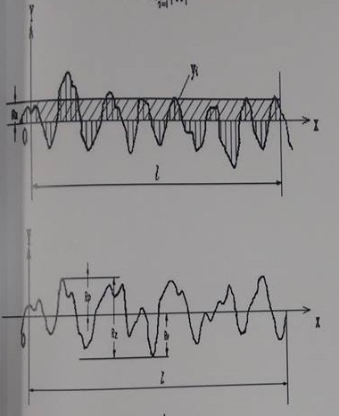

Figure 1 – Surface texture ( Marked with surface parameters )

Surface roughness often shortened to roughness, is a component of surface texture. It is quantified by the deviations in the direction of the normal vector of a real surface from its ideal form. If these deviations are large, the surface is rough; if they are small, the surface is smooth. Roughness is typically considered to be the high-frequency, short-wavelength component of a measured surface (see surface metrology). However, in practice it is often necessary to know both the amplitude and frequency to ensure that a surface is fit for a purpose.

Roughness plays an important role in determining how a real object will interact with its environment. Rough surfaces usually wear more quickly and have higher friction coefficients than smooth surfaces (see tribology). Roughness is often a good predictor of the performance of a mechanical component, since irregularities in the surface may form nucleation sites for cracks or corrosion. On the other hand, roughness may promote adhesion.

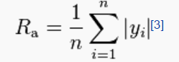

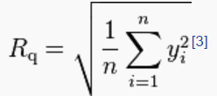







QUALISURF Surface Roughness Tester features high accuracy, wide range of application, simple operation and stable performance. It is widely applicable in testing surfaces of all kind of metals and non-metals. It uses the principle of Cantilever in order to measure the roughness of the surface.

**Important Terminology:-**

Measurement unit: Micrometre (µm)

* **Ra**: Arithmetical Mean Deviation of the profile within the sampling length
* **Rz**: The maximum height of irregularities given by the distance between maximum height of the profile peaks and maximum depth of the profile valley within the sampling length
* **Rq**: Root-Mean-Square Deviation of the profile. Rq is the square root of the arithmetic means of the squares the profile deviation (Yi) from mean within the sampling length
* **Rt**: Total Peak-to-Crest Height

**Device and its Specifications:-**

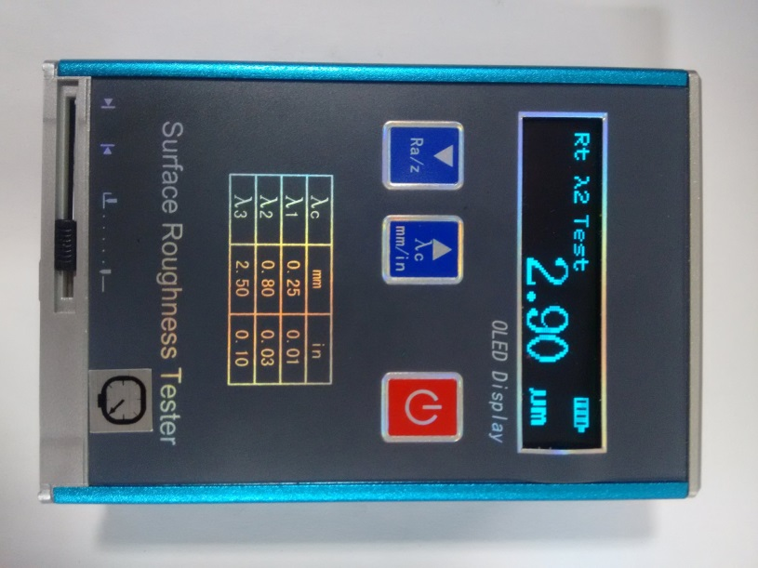

Figure 2 - Qualisurf ( Front View )

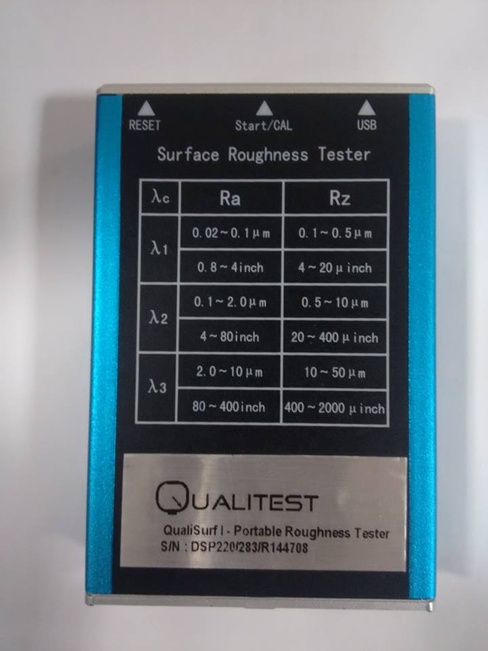

Figure 3 – Qualisurf ( Back view )

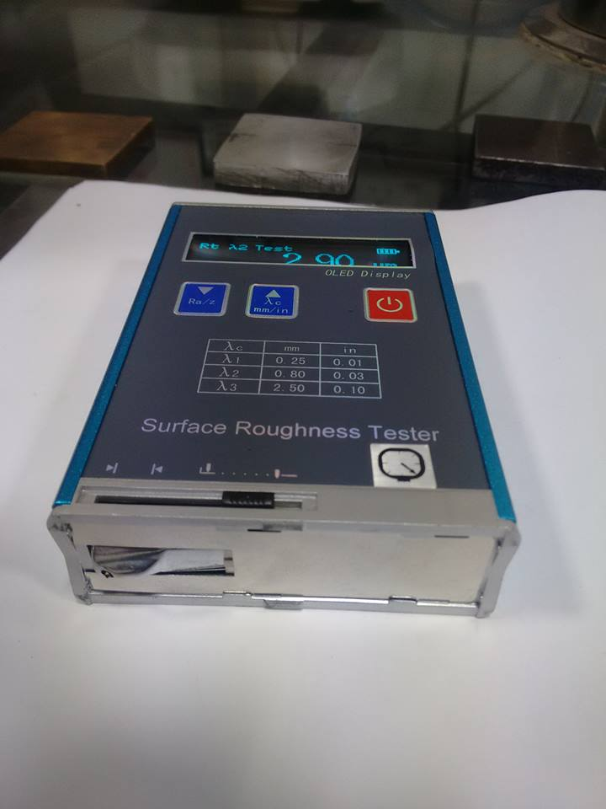

Figure 4 – Qualisurf ( Bottom view )

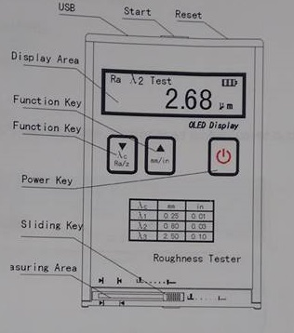

Figure 5 – Device Specification

**Dimension of Sample:-**

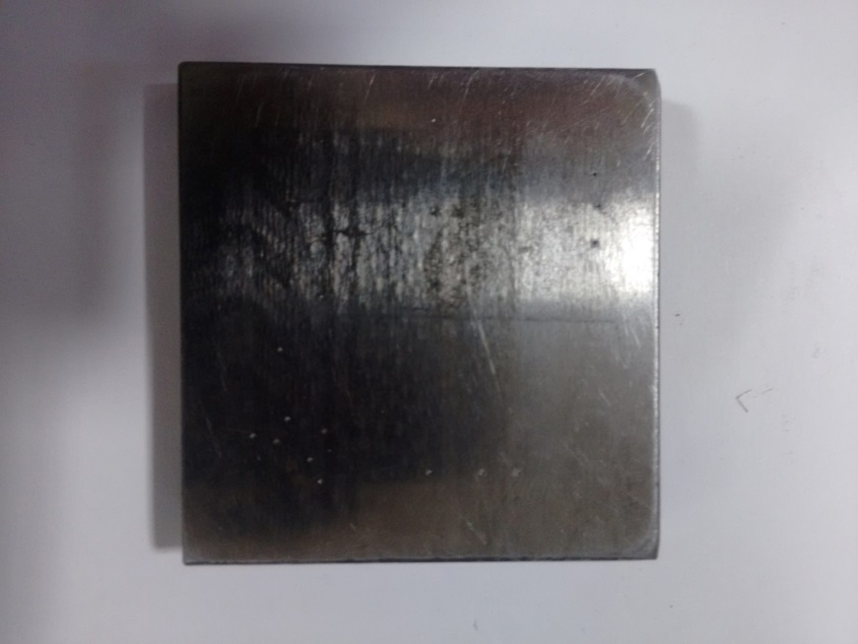

Figure 6 – Aluminium sample

Dimensions: 5.1 cm X 5.0 cm ( Length X Width )

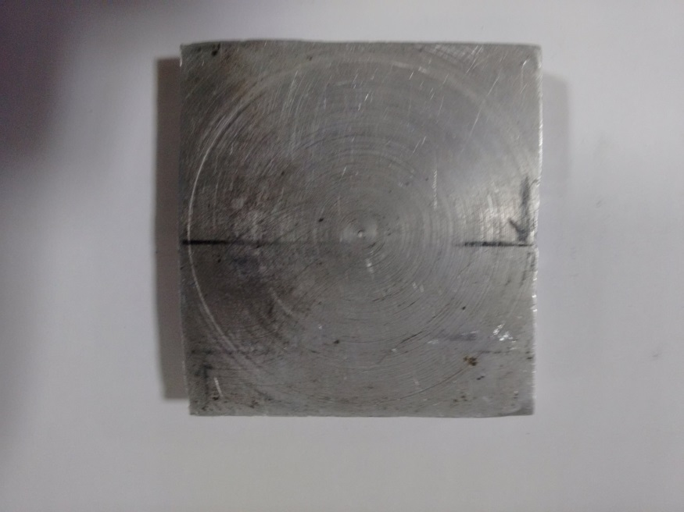

Figure 7 – Mild Steel Sample

Dimensions: 4.9 cm X 4.7 cm

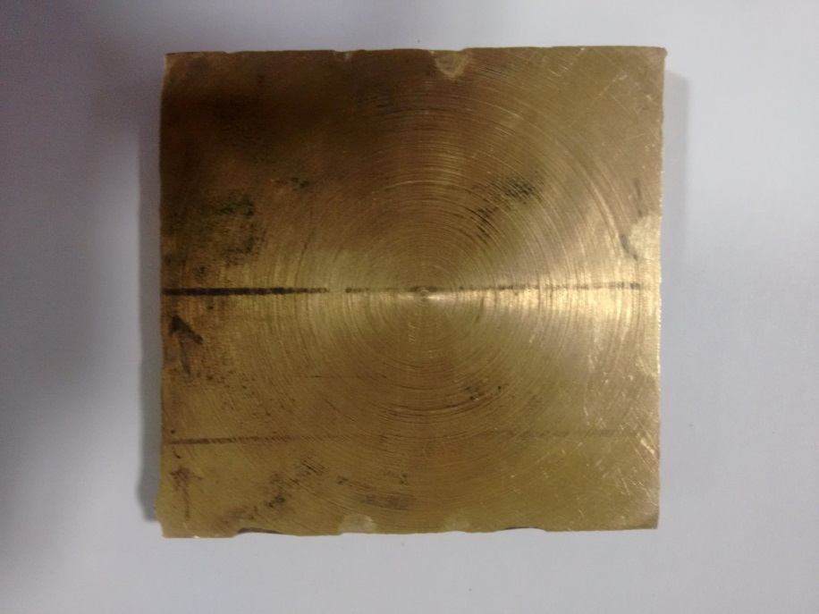

Figure 8 – Brass sample

Dimensions: 5.1 cm X 5.2 cm

**Experimental condition:-**

* Travelling length = 6mm
* Measurement range(µm)

Ra: 0.05- 10

Rz: 0.1- 50

* Tolerance:±15%
* Variation of indication < 12%
* Touch needle tip arc radius and angle of sensor

Tip arc radius: 10µm +- 1µm

Angle: 90+5-10

* The sensor touch needle static force measurement and its rate

Touch needle static force measurement: ≤ 0.016N

Force measurement rate: ≤ 800N/m

Sensor guide head pressure: < 0.05N

**Procedure:-**

* Take the sample material and calibrate the machine using this sample and its indicated value
* Verify this callibration by putting this device over the specified region on the sample.
* Take 3 readings and verify thai it is properly calibrated
* Now, take first sample and specify the region whose roughness is to be measured
* Put the device over specified region and take the reading
* Repeat this until we get the four readings whose difference of maxima and minima doesn’t go beyond 0.05 µm
* Repeat this process over other two samples and note down their reading

**Observation:-**

|  |  |  |  |  |  |  |  |
| --- | --- | --- | --- | --- | --- | --- | --- |
|  |  |  | **Sampling Length = 6mm** | | |  |  |
|  |  |  |  |  |  |  |  |
| **Area** | **Material** | **S. No.** | **Ra(µm)** | **Rz(µm)** | **Rq(µm)** | **Rt(µm)** | **λ(µm)** |
| 5.1 * 5.0 cm2 | **Aluminium** | 1 | 1.05 | 4.26 | 1.2 | 5.62 | λ2 |
| 2 | 1.09 | 4.65 | 1.29 | 6.04 | λ2 |
| 3 | 1.07 | 4.68 | 1.24 | 5.56 | λ2 |
| 4 | 1.04 | 4.47 | 1.23 | 7.12 | λ2 |
|  |  |  |  |  |  |  |  |
| 4.9*4.7 cm2 | **Mild Steel** | 1 | 0.31 | 2.06 | 0.41 | 3.15 | λ2 |
| 2 | 0.32 | 2.05 | 0.41 | 2.68 | λ2 |
| 3 | 0.3 | 2.02 | 0.38 | 2.43 | λ2 |
| 4 | 0.33 | 2.34 | 0.43 | 2.9 | λ2 |
|  |  |  |  |  |  |  |  |
| 5.1*5.2 cm2 | **Brass** | 1 | 1.45 | 7.09 | 1.76 | 8.64 | λ2 |
| 2 | 1.51 | 7.46 | 1.87 | 10.55 | λ2 |
| 3 | 1.5 | 7.44 | 1.88 | 10.24 | λ2 |
| 4 | 1.51 | 7 | 1.85 | 10.23 | λ2 |
|  |  |  |  |  |  |  |  |
|  | **Sample** | 1 | 1.68 | 4 | 1.72 | 4.13 | λ2 |
|  | 2 | 1.66 | 3.81 | 1.69 | 3.9 | λ2 |
|  | 3 | 1.68 | 4.6 | 1.73 | 4.93 | λ2 |

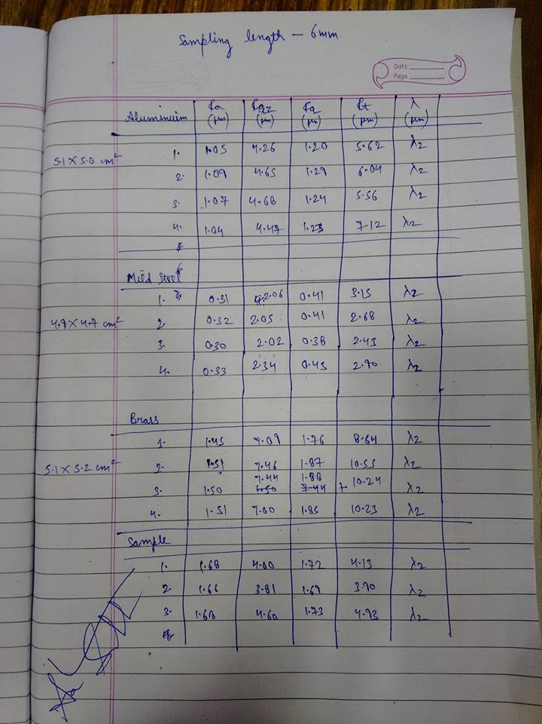

Figure 9 – Observation table

**Calculation:-**

**Aluminium Sample**

Ra(1) = 1.05 µm

Ra(2) = 1.09 µm

Ra(3) = 1.07 µm

Ra(4) = 1.04 µm

Ra(average) = Ra(1)+ Ra(2)+ Ra(3)+ Ra(4)

4

= 1.05+1.09+1.07+1.04

4

= 1.06 µm

Max. Deviation = l 1.09 – 1.06 l

= .03 µm

Ra ( Aluminium ) = ( 1.06 +- .03 ) µm

Similarly

Ra ( Mild Steel ) = ( .31 +- .02 ) µm

Ra ( Brass ) = ( 1.49 +- .04 ) µm

**Discussion:-**

Through this experiment we measured the surface roughness of few samples provided to us using the instrument ‘Qualisurf’. The instrument works on the principle of cantilever and has a movable cantilever head which helps measure the roughness value. Using the instrument we measured the various parameters as average, root mean square etc. values related to surface roughness.

**Conclusion:-**

* Roughness of Aluminium Sample = ( 1.06 +- .03 ) µm

Roughness of Mild Steel Sample = ( .31 +- .02 ) µm

Roughness of Brass Sample = ( 1.49 +- .04 ) µm

* Order of roughness of material Brass > Aluminium > Mild Steel
* Most rough material is Brass
* Least rough material is Mild steel

**Precautions:-**

* The device should be calibrated before testing the samples
* Reading should be taken from the same spot on the sample to avoid deviations in results
* The moving head of the cantilever should make perfect contact with the sample
* The set of readings taken must be convergent

**Reference:-**

* William D. Callister, Jr., and David G. Rethwisch, Material Science and Engineering an Introduction, 8th Ed.
* Fundamentals of material science and engineering by William D. Callister, Jr. 4th edition.
* en.wikipedia.org/wiki/Surface_roughness